# **Worksheet 7 – Histogram operations**

## TASK 1

1. Load ‘lena.jpg’ as an RGB colour 3D matrix.
2. Convert into grayscale and display the image and its histogram next to each other.
3. Work out the RGB histogram and display it next to the colour image. An RGB histogram should look something like this:
4. The two images and two histograms should be displayed as a 2 x 2 subplot.

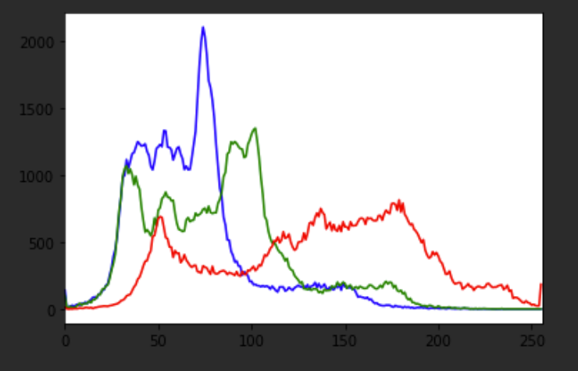

## TASK 2 – Grayscale equalisation

1. Load ‘lena.jpg’ as a grayscale image.
2. Using OpenCV, perform histogram equalisation storing the result in a new array.
3. Use numpy hstack() function to concatenate the original and equalised images.
4. Display the concatenated image, the original histogram and the equalised histogram as in the sample below.
5. 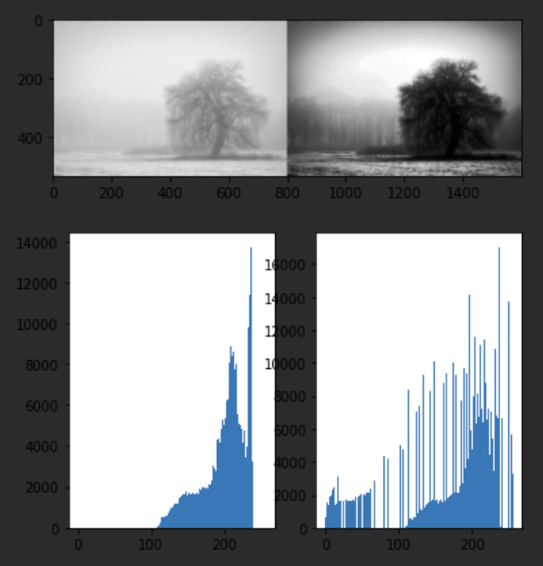Comment on the effects of equalisation.

## TASK 3 (Normalisation)

Equalization attempted to produce a histogram with equal amounts of pixels in each intensity level.  This may result in unrealistic images when applied to RGB images. While equalisation attempts to produce more equal amount of pixels for each intensity, normalization is simpler; it looks for the maximum intensity pixel and a minimum intensity and then will determine a factor that scales the min intensity to 0 and the max intensity to 255. This is applied to every pixel in the image which produces the final result.  
  
**Image Normalization**is a process in which we change the range of pixel intensity values to make the image more familiar or normal to the senses, hence the term normalization. Often image normalization is used to **increase contrast** which aids in improved feature extraction or image segmentation.

1. Load ‘locontrast.jpg’
2. Use: *cv2.normalize(my_img, None, 0, 255, cv2.NORM_MINMAX)*
3. Use numpy hstack() function to concatenate the original and equalised images.
4. Display the concatenated image, the original histogram and the equalised histogram as in the sample below.
5. Comment on the effects of normalization and compare with equalization (TASK 2).

